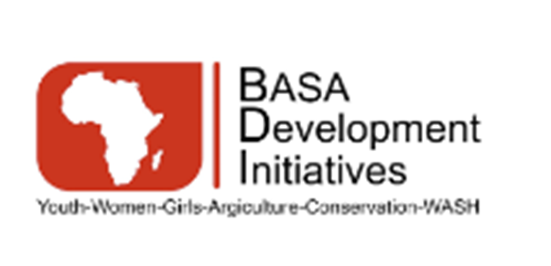
BASA DEVELOPMENT INITIATIVES
Policy on Mandatory PSEA Training, Capacity Building, and Certification

Effective Date: 15 January 2026
Approved by: Board of Directors
Policy Owner: Safeguarding / PSEA Focal Point
Applies to: All personnel and affiliated individuals
Purpose
This policy establishes BASA Development Initiatives’ requirements for mandatory Prevention of Sexual Exploitation and Abuse (PSEA) training for all personnel. The policy ensures that staff and associated personnel understand their responsibilities, recognize risks, apply appropriate standards of conduct, and know how to prevent, report, and respond to SEA in a survivor-centered and child-sensitive manner. The policy aligns with UNICEF PSEA Minimum Standards and United Nations safeguarding guidance.
Scope and Applicability
This policy applies to all individuals engaged by BDI, including permanent and temporary staff, consultants, volunteers, interns, board members, advisors, partner personnel working under BDI-led activities, and any individual representing BDI in program implementation or community engagement. The training requirements apply regardless of contract modality or duration.
Mandatory PSEA Training Requirement
All personnel must complete mandatory PSEA training as a condition of engagement with BDI. PSEA training is required at onboarding before personnel assume duties involving beneficiaries or communities and must be completed annually thereafter. No personnel may commence fieldwork or program implementation without documented completion of initial PSEA training, except under exceptional circumstances approved in writing by senior management with interim risk-mitigation measures in place.
Failure to complete required PSEA training may result in suspension of duties, withholding of contract confirmation, or disciplinary action.
Required PSEA Training Content
BDI’s PSEA training curriculum shall cover, at a minimum, the five required content elements expected by UNICEF.
First, the training shall provide a clear explanation of sexual exploitation and abuse, including definitions, prohibited behaviors, power dynamics, and contextual risks within humanitarian and development programming. This includes distinctions between SEA, sexual harassment, and consensual relationships, with emphasis on the prohibition of sexual activity with beneficiaries.
Second, the training shall explain BDI’s standards of conduct, including the Code of Conduct, PSEA policy commitments, individual responsibilities, and the consequences of non-compliance. Personnel must understand that SEA constitutes gross misconduct and may lead to termination and referral to authorities.
Third, the training shall detail reporting obligations and mechanisms, including how, when, and where to report SEA concerns or allegations. This includes internal reporting channels, confidentiality requirements, protection from retaliation, and the obligation to report suspicions or disclosures, even in the absence of proof.
Fourth, the training shall address survivor-centered and child-sensitive response principles. Personnel must understand how to respond appropriately to disclosures, prioritize safety and dignity, avoid re-traumatization, and refer survivors to appropriate services without conducting investigations or interviews beyond their role.
Fifth, the training shall clarify roles and responsibilities within BDI’s PSEA system, including the functions of management, Human Resources, the PSEA Focal Point, investigators, and partner organizations. This includes expectations for cooperation with investigations and safeguarding processes.
Training Modalities and Delivery
PSEA training may be delivered through in-person workshops, virtual sessions, blended learning, or approved external training platforms, depending on operational context. Training materials must be adapted to local realities, languages, literacy levels, and roles, with additional tailored sessions provided for managers, supervisors, field staff, and personnel working directly with children or highly vulnerable populations.
Refresher training shall be conducted annually and whenever significant policy updates occur or safeguarding risks increase.
Training Attendance and Certification Tracking
BDI shall maintain a centralized system for tracking PSEA training attendance and certification. Records shall include participant names, roles, training dates, training modality, trainer or provider, and certification status. Certificates of completion or signed attendance records must be retained in personnel files and safeguarded records.
Human Resources, in coordination with the PSEA Focal Point, is responsible for monitoring compliance and following up on overdue or incomplete training requirements. Training records must be made available for donor audits and safeguarding assessments upon request.
Roles and Responsibilities
Senior management is responsible for ensuring institutional commitment, resourcing, and enforcement of this policy. The Safeguarding or PSEA Focal Point is responsible for coordinating training delivery, updating training materials, ensuring alignment with UNICEF standards, and advising on role-specific training needs. Human Resources is responsible for integrating PSEA training into onboarding processes, tracking completion, and maintaining personnel records. All personnel are responsible for participating fully in required training and applying PSEA principles in their work.
Compliance, Monitoring, and Review
Compliance with this policy is mandatory and subject to internal monitoring and donor review. Non-compliance may result in corrective action, disciplinary measures, or termination of engagement. This policy shall be reviewed periodically to reflect evolving UNICEF requirements, lessons learned, and changes in BDI’s operating context.
Related Documents
This policy should be read in conjunction with BDI’s Code of Conduct, PSEA Policy, Reporting and Complaints Procedures, SEA Investigation Procedures, and Training Materials.

